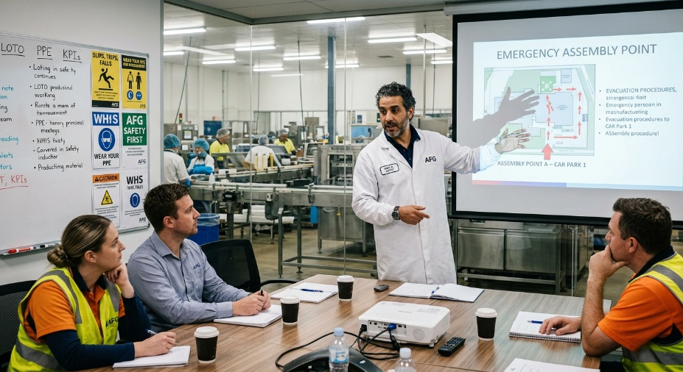
Learner #5: Samir Al-Fassi

About Me: | Samir is a 41-year-old Senior Production Lead at Aussie Juice Co.'s Northern Adelaide plant, where he runs the glass bottling line and a team of six operators. He migrated to Australia from Morocco in 2016 and lives in Adelaide's northern suburbs with his wife and three children. Arabic is his first language, French his second from school in Casablanca, and English his third; on the production floor and around the plant, his English is fluent and confident, and he is widely respected by his crew and the QA team.
Professional and Learning Experience: | Samir holds a Certificate II in Food Processing (FDF20120, 2019), a Statement of Attainment for HACCP Principles Level 2 (2021, current), HLTAID011 Provide First Aid (current), a White Card, and an internal Lock-Out-Tag-Out competency sign-off. He has eight-plus years of hands-on glass-line experience at Aussie Juice Co., the last two as Senior Line Lead.  He has personally inducted and signed off more than forty new production staff since stepping into the lead role in 2024, runs structured Tell-Show-Do sessions for individual operators (his Toby Miller capper-jam training plan is a recent example), and recently facilitated a 45-minute group induction for three cross-departmental staff in Training Room A. Samir is enrolled in TAE40122 with full employer sponsorship.
Career/Training Goals: | Samir wants to transition into a formal workplace training role within the food manufacturing sector, ideally building on the safety, HACCP, and packaging-process content he already delivers informally. His Plant Manager has earmarked him for the Lead Trainer position once he holds Cert IV, and the longer-term goal is to take ownership of the site's full induction programme and convert his existing informal “cheat sheets” into formal Standard Operating Procedures.
Working Style and Preferences: | Samir is methodical, rule-based, and unfailingly consistent. He is at his strongest in structured one-on-one training where he can use a script, a checklist, and a physical demonstration; his recent capper-jam session followed the Tell-Show-Do model exactly as written and produced a clean, traceable record. In group settings he tends to lean heavily on his slide deck and his manager has asked him to develop more interactive group activities to keep administrative staff engaged.  Samir has shared that he reviews and rehearses his slide decks the night before any group session and that he has a small notebook of “set phrases” he uses for the technical content because he wants to make sure the wording is precise and unambiguous. Idioms, colloquialisms, and Australian slang on site occasionally need a moment of clarification, particularly when delivered quickly or in a Q&A context, and he has mentioned that following fast-paced multi-speaker discussions is more tiring than the equivalent in written form. His written English is grammatically careful but tends to be slightly formal, and he uses translation tools and a French-English dictionary when working on longer reports.  Samir is comfortable with the plant's HMI systems, the QA reporting platform, and Microsoft Office basics, and he has his own laptop and a stable home internet connection.
Additional Information: | Samir prays five times daily and observes Ramadan, which can affect his energy and concentration during late-afternoon sessions during the fasting period. He is heavily involved in his children's school community and a local cultural association in the northern suburbs. His preferred way of learning new content is to receive any reading materials in advance so he can work through them in his own time before the live session, and he has mentioned that having a written copy of any verbal instructions or assessment questions is genuinely helpful.

